Your Paper's Title Starts Here: Center
Use Times New Roman 14 Bold Font
First Author^{1*}, Second Author² and Last Author³
¹Full address of first author, including email
²Full address of second author, including email
³List all distinct addresses in the same way
(*Mark the corresponding author with an asterisk Start each address on new line, font size 11, centered)
For the rest of the paper, use Times Roman (Times New Roman), font size: 12
Abstract. This template explains and demonstrates the format guidelines for authors preparing papers for publication in the proceedings of Geo-Innovations 2014. Read these instructions carefully and follow the outline of this text. Please make the page settings of your word processor to A4 format (21 × 29.7 cm or 8 × 11 inches); with the margins: bottom 1.5 cm (0.59 in) and top 2.5 cm (0.98 in), right/left margins must be 2 cm (0.78 in). The maximum number of words for the abstract is 200.
Keywords: List the keywords (maximum six) that describe the contents of your paper. All keywords should be lowercased, separated by a comma and a space (one, two, three)
Introduction
The section headings are in boldface capital and lowercase letter, font size 12, bold and left justified. All manuscripts must be in English. The final manuscript must not exceed eight (8) pages total, including figures, tables and references. The text should be left and right justified, font size 12. SI units should be used in their accepted abbreviated form. All symbols should be specified and spelled out for the first time. You can use this document as both an instruction set and as a template into which you can type your own text.
Should authors use tables or figures from other Publications, they must ask the corresponding publishers to grant them the right to publish this material in their paper.
Use italic for emphasizing a word or phrase. Avoid using boldface typing or capital letters except for section headings. Second level headings are typed as part of the succeeding paragraph (Refer to the section headings below). Number the pages of your paper sequentially as shown in this template using Times New Roman size 12 at the bottom right corner of each page. Do not number the sections of your paper.
Experimental
Tables. Tables (refer with: Table 1, Table 2) should be presented as part of the text, but in such a way as to avoid confusion with the text. A descriptive title should be placed above each table.

Table 1. Enrollment in local colleges, 2005 (Table text and caption should centered)
College | New students | Graduating students | Change
University A | 110 | 103 | +7
University B | 223 | 214 | +9
Source: Fictitious data, for illustration purposes only
Special Signs. for example , α γ μ Ω () ≥ ± ● Γ {110} should always be written in with the fonts Times New Roman, especially also in the figures and tables.

Macros. Do not use any macros for the figures and tables. (We will not be able to convert such papers into our system)
Result and Discussion
Language. All text, figures and tables must be in English.

Figures. Figures (refer with: Fig. 1, Fig. 2) also should be presented as part of the text, leaving enough space so that the caption will not be confused with the text. The caption should be self-contained and placed below the figure. Generally, only original drawings or photographic reproductions are acceptable. Only very good photocopies are acceptable. Utmost care must be taken to insert the figures in correct alignment with the text. Half-tone pictures should be in the form of glossy prints. If possible, please include your figures as graphic images in the electronic version. For best quality the pictures should have a resolution of 300 dpi (dots per inch). Color figures are welcome.

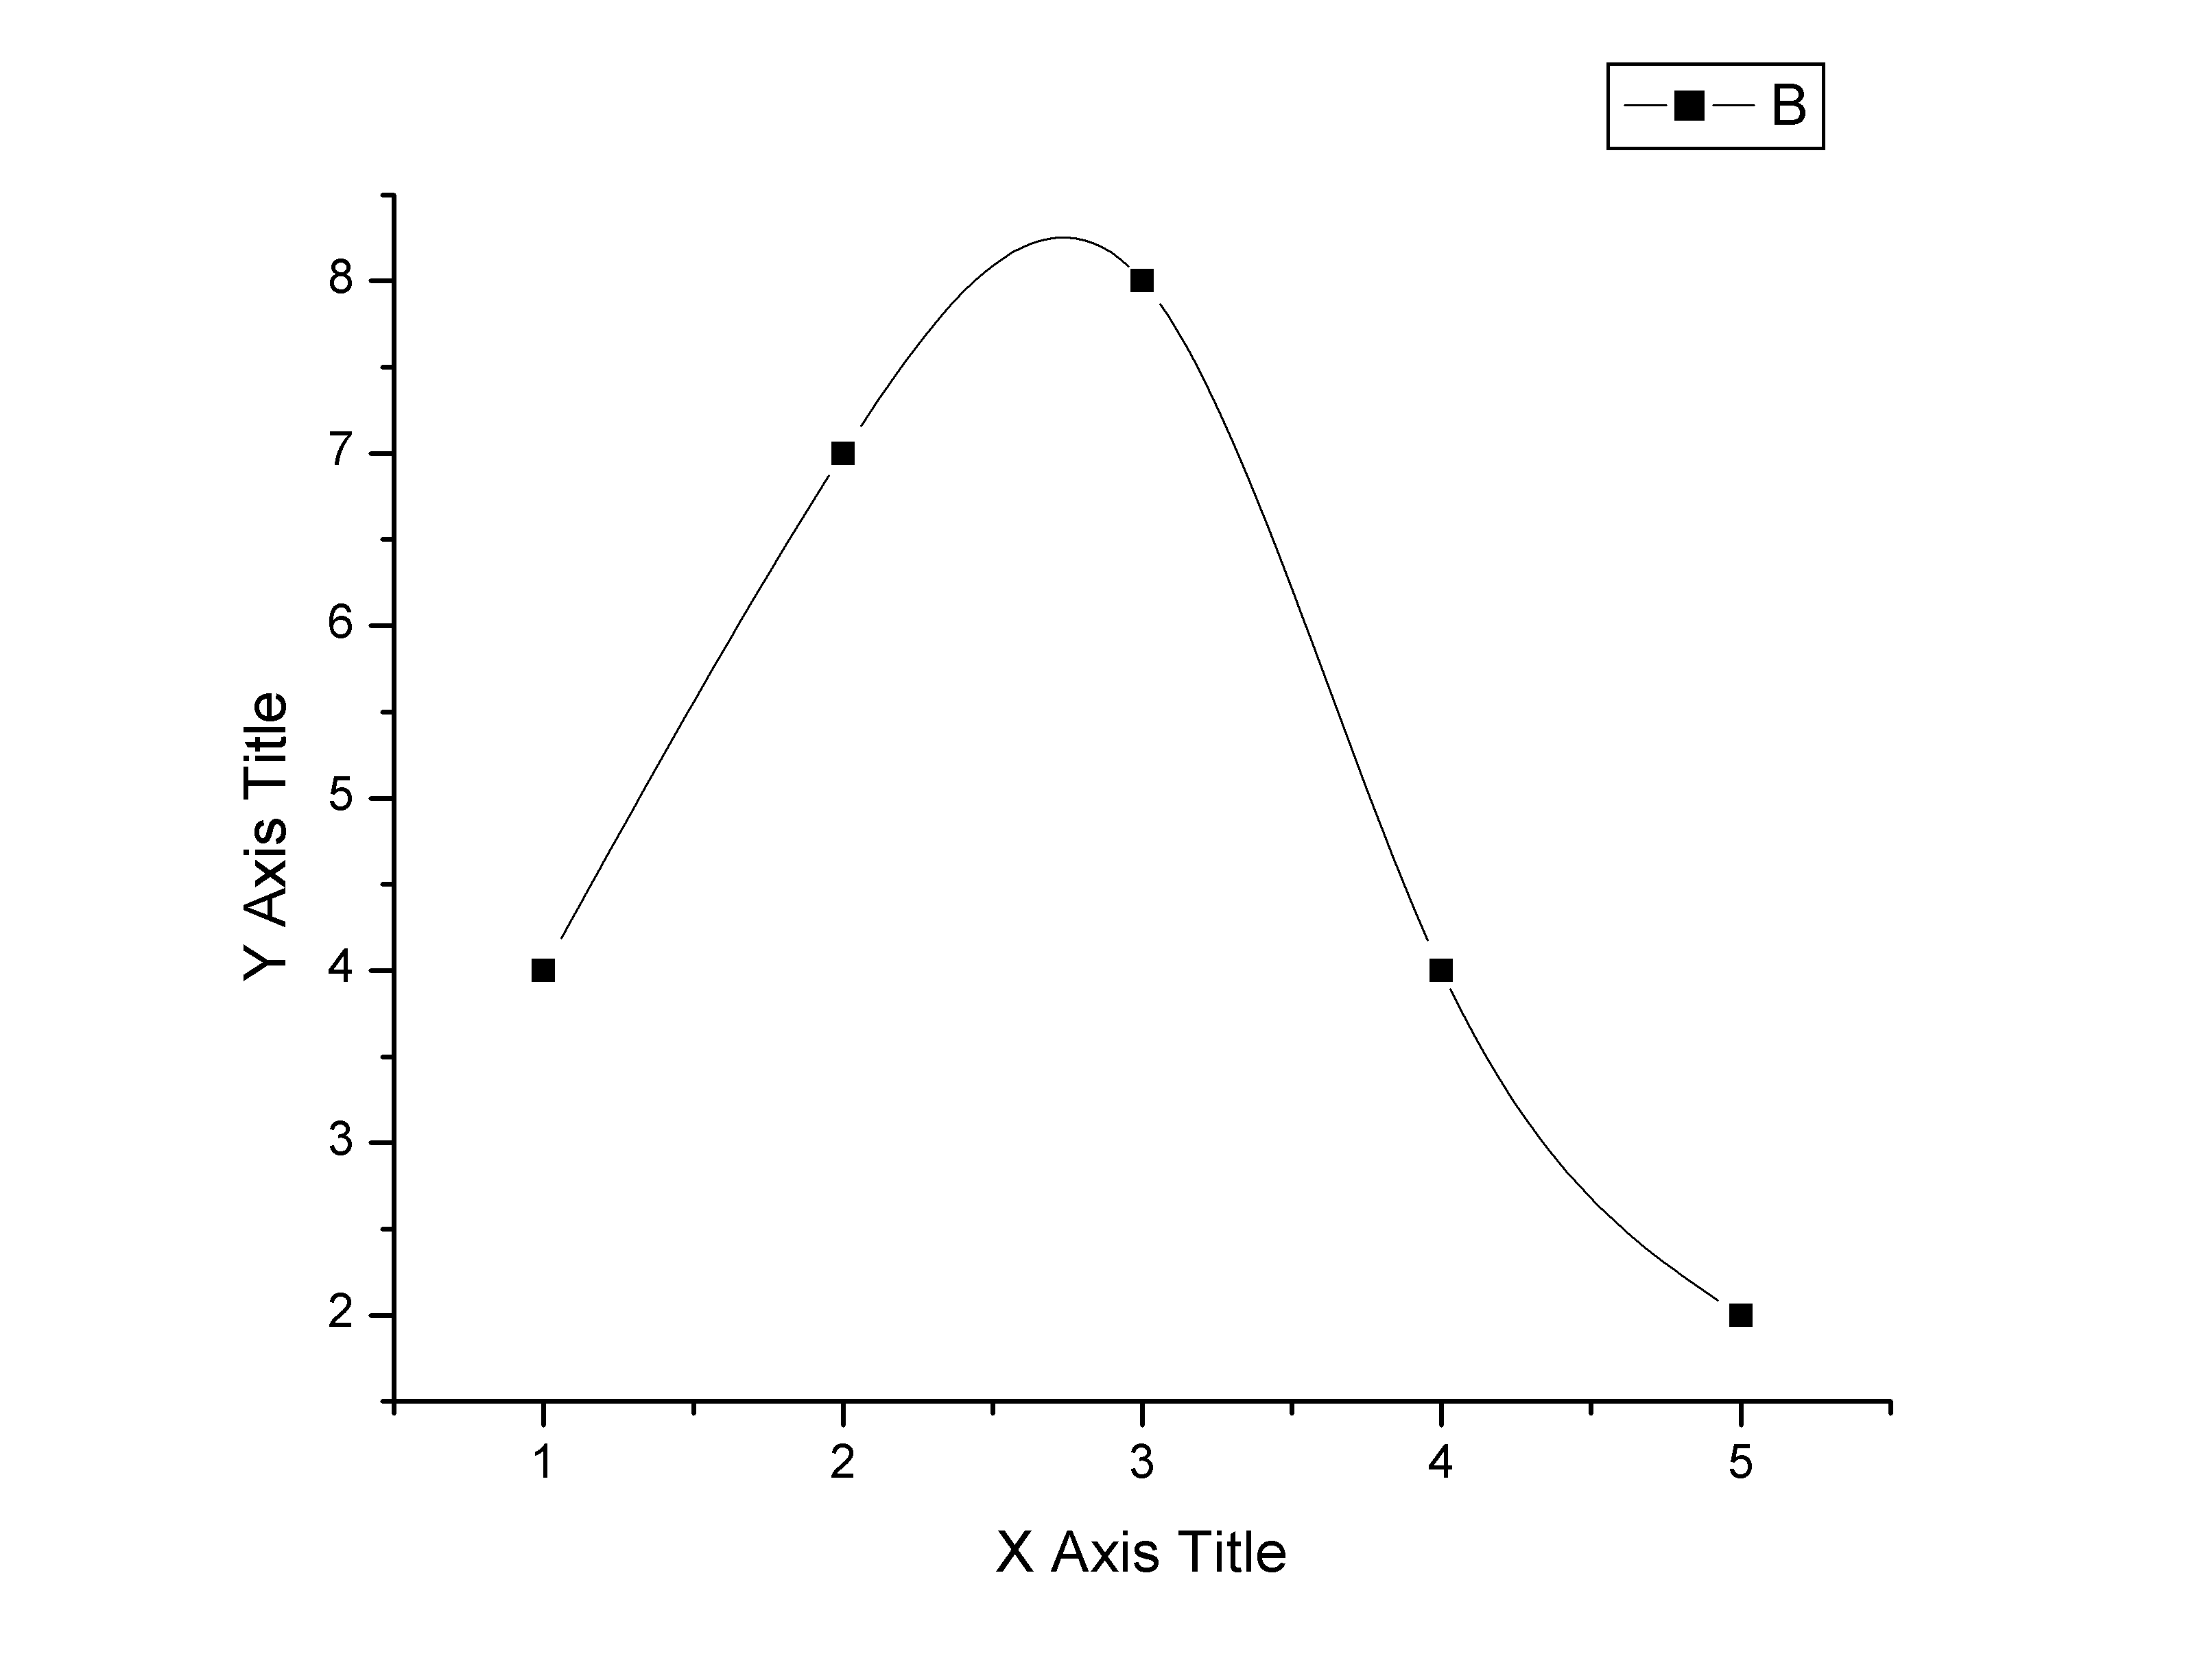
Figure 1. [illustration text and caption should centered, font size 12, included in body text]

Equations. Equations (refer with: Eq. 1, Eq. 2) should be indented 5 mm (0.2"). There should be one line of space above the equation and one line of space below it before the text continues. The equations have to be numbered sequentially, and the number put in parentheses at the right-hand edge of the text. Equations should be punctuated as if they were an ordinary part of the text. Punctuation appears after the equation but before the equation number. The use of Microsoft Equation is allowed.
c² = a² + b². (1)

Conclusions
The authors must follow the instructions given in the document for the papers to be published and to facilitate a problem-free publication process.
Literature References. References are cited in the text just by square brackets [1]. Two or more references at a time may be put in one set of brackets [3,4]. The references are to be numbered in the order in which they are cited in the text and are to be listed at the end of the paper under a heading References, see our example below.
Acknowledgment
This should be included whenever appropriate as a separate section before Reference section, font size 12.
References
[1]. Gamelin FX, Baquet G, Berthoin S, Thevenet D, Nourry C, Nottin S, Bosquet L (2009) Effect of high intensity intermittent training on heart rate variability in prepubescent children. Eur J Appl Physiol 105:731-738.
[2]. Slifka MK, Whitton JL (2000) Clinical implications of dysregulated cytokine production. J Mol Med. doi:10.1007/s001090000086
[3]. South J, Blass B (2001) The future of modern genomics. Blackwell, London
[4]. Brown B, Aaron M (2001) The politics of nature. In: Smith J (ed) The rise of modern genomics, 3rd edn. Wiley, New York, pp 230-257
[5]. Cartwright J (2007) Big stars have weather too. IOP Publishing PhysicsWeb. http://physicsweb.org/articles/news/11/6/16/1. Accessed 14 August 2014.
[6]. Trent JW (1975) Experimental acute renal failure. Dissertation, University of California

